

**Vol. 3, Issue • Fall 2016**

**WHAT WOULD YOU DO?**

My guess is that you would not waste one millisecond getting the kids off of the beam. Nobody wants to see a child injured! To that end, I am certain none of us want to see any adults injured either. Yet, would we intervene as quickly if the photo above contained “grown-ups”?

The most likely answer is…….Maybe, maybe not. Why are we so willing to Get Awkward to protect a child’s health, but less inclined to protect adults; more importantly, those we work with? Lets’ explore a little:

* **Only 2 in 5 people intervene in unsafe conditions (39%)**
  + Typically this is due to organizational climate or “norms” that constitute an organizations’ culture.
  + People fail to intervene because they are concerned the person will become angry.
  + Other times they are convinced it will not make a difference (we have always done it that way).
* **Why Get Awkward?**
  + Nearly 60% of people say that when they do something unsafe it is because: “I did not realize it was unsafe.”
  + 85% of people surveyed say they want somebody to intervene when they are seen doing something unsafe.
* **So…..What do we do?**
  + Don’t assume people are doing something unsafe because they are “stupid” or lack “common sense”. Remember….the majority of people (60%) don’t know they are doing something unsafe.
  + Attempt to be helpful in your Get Awkward moment. DO NOT be confrontational or condescending.
  + Ask questions, try to understand why the person is performing an unsafe behavior. Many times they will arrive at alternative safe behaviors all on their own.

**HUDDLE FOR WORK!**



All work days must begin with a “Safety Huddle.” Why is this important? Why does Gallagher/CTL/Shepley require it?

* Reduce accidents/incidents.
* Improve safety.
* Reduce issues and increase productivity by ensuring the whole crew is “on the same page.”
* Foster teambuilding and better teamwork.
* Engage and involve people in their work.
* Ensure we have the right tools for the job.
* Allow us to openly discuss any potential issues.
* We plan our day, rather than react to it.

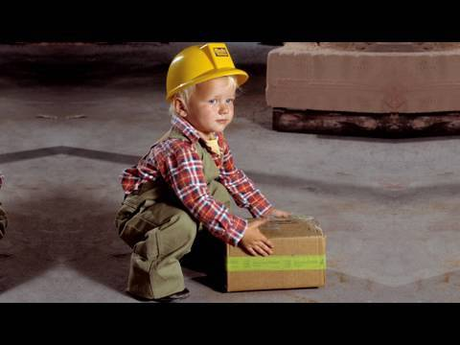

Toddlers lift this way naturally…it is instinctual. Do you?

**AUTUMN HOME AND FAMILY SAFETY TIPS**

* **Chimneys and Furnaces**
  + Have your chimney inspected annually.
  + Make sure to burn dry wood.
  + Do not burn cardboard or trash, they cause sparks and could lead to a chimney fire.
  + Smaller hotter fires burn more completely and produce less smoke than large fires.
* **Trick or Treat Safety**
  + Make sure all Halloween costumes are labeled as “Flame-Retardant”.
  + Rather than buy a mask, use makeup to all
  + Remind children to skip houses that are not well lit.
  + Check candy before allowing children to eat it.
* **Yard Work**
  + When lifting bags of mulch, lift with your legs, not your back. See the photo above.
  + Wear gloves to avoid getting blisters.
  + Never prune from a ladder.
  + Store gas and oil in only approved containers.
* **Pet Safety**
  + Antifreeze is toxic to pets. Keep it off the floor and in sealed containers.
  + Chocolate is toxic to dogs, cats, and birds. Keep your Halloween and Thanksgiving treats out of their reach.
  + Indoor pets should not be left outside for extended periods of time. Pets can get hypothermia too.
* **Home/Family Safety**
  + Change your smoke and carbon monoxide detector batteries when the time changes.
  + Make sure carbon monoxide detectors are on every level of your home.
  + Get a Flu Shot.
  + Cover your cough and sneezes. Coughing into the inside of your elbow/upper sleeve is most effective.
  + Wash hands for at least 20 seconds.
  + Replace expired fire extinguishers in your home and garage.
  + Hire a professional to check your heating system prior to use.

**Safety Pays!!!!**

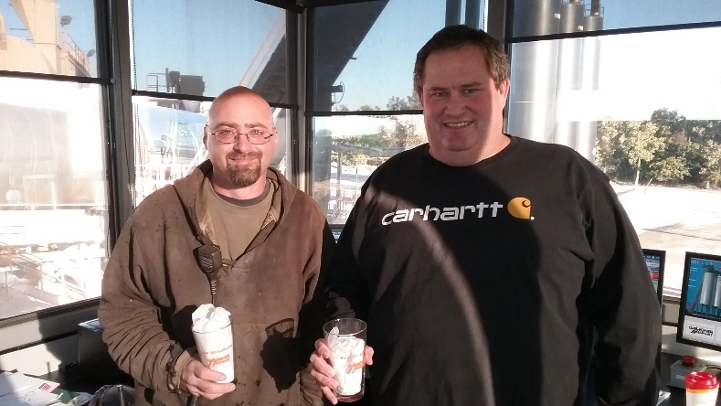

Congratulations to Ken Odegaard and Ryan Burdick from the Joliet Plant when they won the recent contest “Name the Pinch Points in your Workplace.” Great Job Guys!