WELCOME TO SAFETY MATTERS

Volume 1, Issue 1, August 2014
This is the first edition of a quarterly safety newsletter focused on addressing, discussing and improving our safety culture at Gallagher Asphalt. Safety is our top priority, and providing a direct platform to highlight our safety responsibilities will help make us the safest possible asphalt company we can be.

We are now holding ourselves to a higher standard of safety in order to keep all of our co-workers safe, as well as improving the overall quality of our work. Each quarter we will be reviewing accident reports in order to measure our progress as a company. We have brought on consulting firm Network Safety Consultants to immediately address safety issues. Network Safety Consultants, Travelers Insurance and I will perform separate job site safety inspections to guarantee comprehensive safety procedures for all jobs.

Gallagher Asphalt also recently held it’s first meeting of the newly developed Accident Review Board. This board was organized in the spring of 2014 and is overseen by Charlie Gallagher, Dan Gallagher, Patrick Gallagher, Gary Glader of Network Safety Consultants and myself. Gallagher’s management team will select the incidents to be reviewed by the Accident Review Board. These will include incidents that resulted in injuries, motor vehicle accidents, near misses and/or property damage. The Accident Review Board is responsible for reviewing the root cause of the incident, who or what is responsible for the incident, a timeline and corrective action where violations of Gallagher’s safety policies and procedures resulted in accidents or injuries. Gallagher Asphalt takes the safety of our co-workers very seriously, so the board’s primary focus is preventing the recurrence of similar incidents in the future.

- Dan Darden
ACCIDENT REVIEW BOARD MEMBERS:
Charlie Gallagher | Dan Gallagher
Patrick Gallagher | Dan Darden
Gary Glader (Network Safety Consultants)

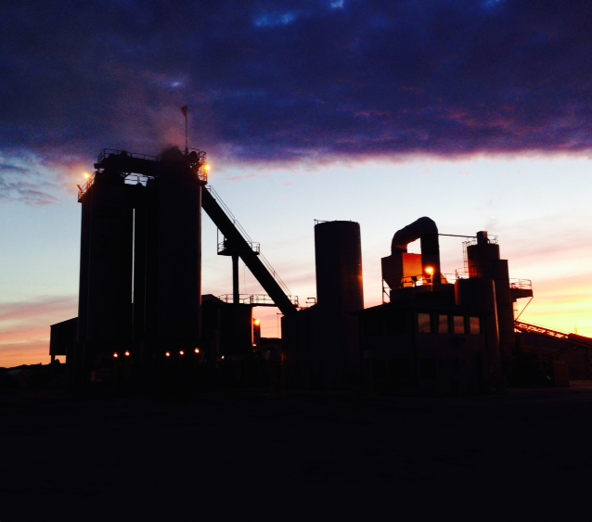
SAFETY IS AN ATTITUDE
Safety is not something you can take or leave alone. It is not an activity in which one participates only when one is being watched or supervised. Safety is not posters, slogans and rules; nor is it movies, meetings, investigations or inspections. Safety is an attitude, a frame of mind. It is the awareness of one’s environments and actions, all day, every day. Safety is thinking about what is going on, knowing what can injure anyone or anything, knowing how to prevent that injury and then acting to prevent it. All it requires is intelligence and a reasonable amount of native ability to see, to hear, to smell and to think. To ignore safe practices does not indicate bravery, only foolishness. To do things safely and correctly is the mark of a wise person, not a timid one.

QUARTERLY REPORT CARD
 | Paving Incidents | $  Amt. | Trucking Incidents | $  Amt. | Total
2nd Q 2013 | 7 | 9,998 | 0 | 0 | 9,998
2nd Q 2014 | 3 | 1,000 | 3 | 4,787 | 5,787
‘13 vs ‘14 | -4 | -8,998 | +3 | +4,787 | -4,211

